Tosca Email Copy

Subject: Get your Tosca tickets before they're gone!

Tosca header image

An opera about love, murder, and redemption.

The Philadelphia Orchestra and one of the world’s leading opera conductors, Yannick Nézet-Séguin, present Puccini’s *Tosca*. Featuring a cast of rising stars and accomplished opera names this semi-staged production is a must-see.

BUY TICKETS (<https://tickets.philorch.org/reserve/index.aspx?performanceNumber=31199&redirect=true&applied=true>)

Hear Yannick describe the cast and some of his favorite moments from *Tosca*.

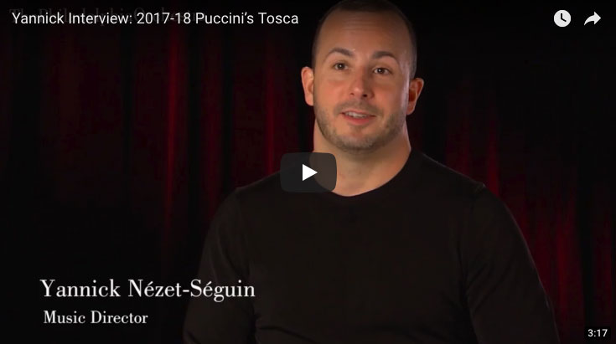

**The Cast**

Critics are raving about these stars.

**Jennifer Rowley**  
Playing the role of: Floria Tosca (the star)

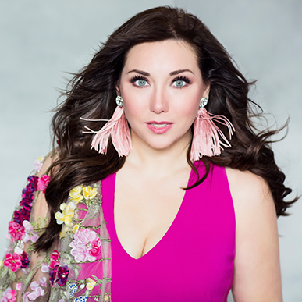

“Her Tosca is young and vibrant, with the emotional life of a teenager, but one who grows up quickly.”

—*The Philadelphia Inquirer*

"Up and coming American soprano Jennifer Rowley has boldly claimed for herself a new, career-changing role. Puccini’s Tosca is a monumental climb for a soprano, a career-defining mountain if, perhaps, not the toughest vocal peak.”

—*Brian Taylor, ZealNYC*

**Yusif Eyvazov**Playing the role of: Mario Cavaradossi (the lover)

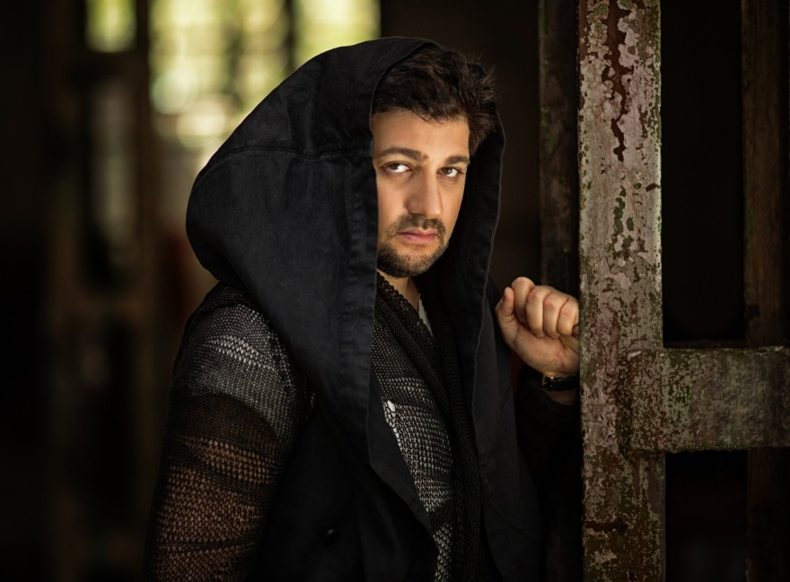

“[Mr. Eyvazov] … sings with burly sound touched with a metallic glint. His big top notes have stinging power.”

—*The New York Times*

“… he’s a very intelligent singer with a stable sense of rhythmic precision and nuanced phrasing.”

—*Operawire.com*

Meet More(https://www.philorch.org/blog/news/who%E2%80%99s-who-tosca-cast#/)

**The Director’s Concept** (https://www.philorch.org/blog/news/director%E2%80%99s-concept-tosca#/)

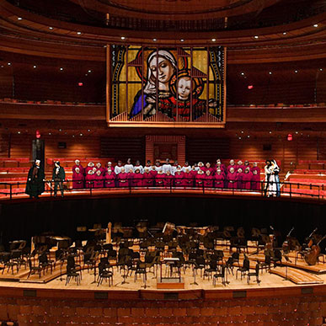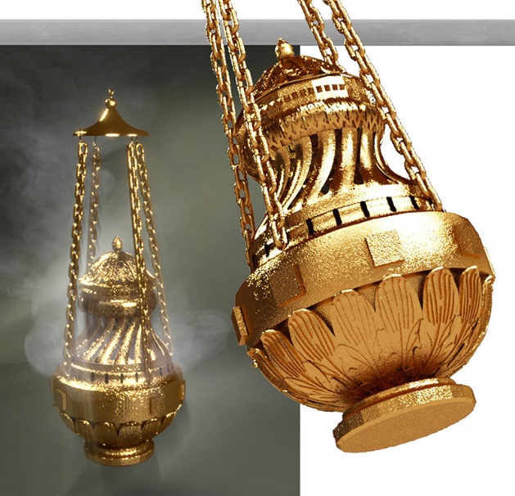

**“**Such interior moments perhaps justify the less-theatrical circumstances of Verizon Hall, where scenery won’t get in the way of fundamental emotions. Another potential plus is hearing the Philadelphia Orchestra discovering the rich Puccini score.”

—*The Philadelphia Inquirer*

[Read more](http://email.wordfly.com/click?sid=MTkxXzEzNTMzXzY3NzBfNjc1NA&l=b73fc9e4-be48-e811-8416-e41f1345a486) about the Orchestra's role throughout the opera.

Tosca   
**Saturday, May** **12** 8 PM  
**Wednesday, May 16** 7:30 PM  
**Saturday, May 19** 8 PM

**Yannick Nézet-Séguin**Conductor

**Jennifer Rowley**Soprano (Tosca)

**Yusif Eyvazov** Tenor (Cavaradossi)

**Ambrogio Maestri**Baritone (Scarpia)

**Richard Bernstein** Bass (Angelotti)

**Kevin Burdette**Bass (Sacristan)

**Greg Fedderly** Tenor (Spoletta)

**Federico De Michelis**Bass-baritone (Sciarrone)

**André Courville** Bass-baritone (A Jailer)

**Cameron Bowden**Boy Soprano (A Shepherd Boy)

**Philadelphia Symphonic Choir**

**Joe Miller** Director

**Philadelphia Boys Choir**

**Jeffrey R. Smith**Artistic Director

**James Alexander** Stage Director

**Puccini** *Tosca*

These concerts are part of the Fred J. Cooper Memorial Organ Experience, supported through a generous grant from the Wyncote Foundation.

These performances are generously sponsored by and dedicated to the memory of Mrs. Jacqueline Desmarais.

BUY TICKETS: (<https://tickets.philorch.org/reserve/index.aspx?performanceNumber=31199&redirect=true&applied=true>)

LEARN MORE: <https://www.philorch.org/concert/17-18/tosca?date=2018-05-12_20-00#/>

**New seats just released!**

**Yannick and Hélène: A Musical Partnership for the Ages  
Thursday, May 10** 7:30 PM **Friday, May 11** 8 PM

**Yannick Nézet-Séguin** Conductor **Hélène Grimaud** Piano

**Brahms** Piano Concerto No. 1 **Schumann** Symphony No. 4

The May 10 concert is sponsored by Osagie and Losenge Imasogie.

The May 11 concert is sponsored by (American Airlines logo)

BUY TICKETS: https://tickets.philorch.org/reserve/index.aspx?performanceNumber=31020&redirect=true

LEARN MORE: https://www.philorch.org/concert/17-18/yannick-and-h%C3%A9l%C3%A8ne?date=2018-05-10_19-30#/

**Yannick and Hélène: A Musical Partnership for the Ages  
Thursday, May 17** 7:30 PM **Sunday, May 20** 2 PM

**Yannick Nézet-Séguin** Conductor **Hélène Grimaud** Piano

**Dvořák** *Othello* Overture **Beethoven** Piano Concerto No. 4 **Beethoven** Symphony No. 7

The May 17 concert is sponsored by (Ballard Spahr logo)

The May 17 concert is sponsored by Jack and Ramona Vosbikian.

BUY TICKETS: <https://tickets.philorch.org/reserve/index.aspx?performanceNumber=31020&redirect=true>

LEARN MORE: <https://www.philorch.org/concert/17-18/yannick-and-h%C3%A9l%C3%A8ne?date=2018-05-10_19-30#/>

Friends box

Footer